Starters Guide – Programming Alice 2.2 in Eclipse
Requirements:
- Eclipse IDE for Java Developer from http://www.eclipse.org/downloads/
- Java SE Development Kit from http://www.oracle.com/technetwork/java/javase/downloads/index.html
- Alice 2.2 source code from http://alice.org/
- Latest version of Alice 2.2 from http://alice.org/index.php?page=downloads/download_alice2.2#

Creating a project in Eclipse
- Create a new Java Project / Project.
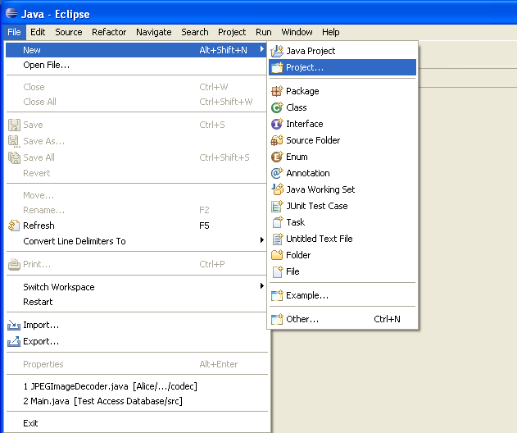

- Name your Project, and then click Next.

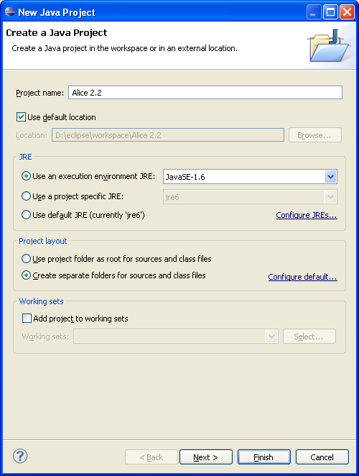

- Click Link additional source.
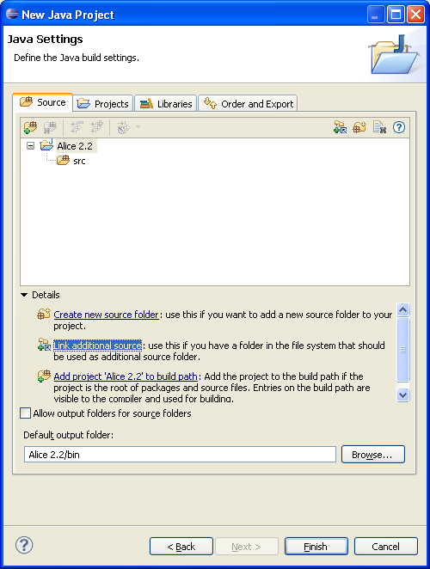

- Browse to the location of your Alice 2.2 source folder, select the folder (not contents in the folder), then click Finish.

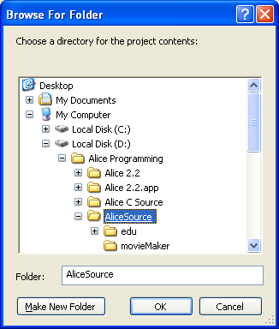
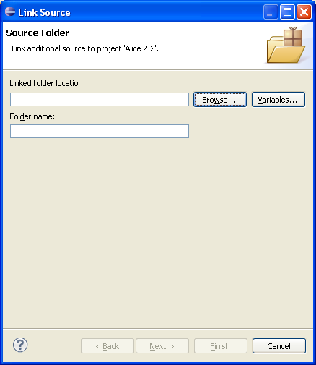

Note: You can delete the src folder. We only need the AliceSource folder.
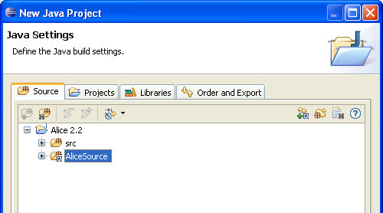
- Click the Libraries tab, and the Add External JARs… button.
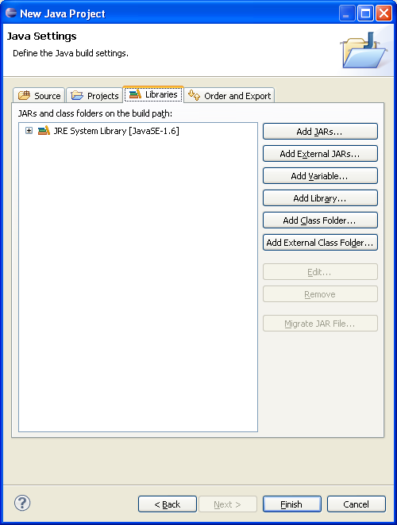

- Browse to your Alice 2.2 – Required – externalLib folder and select all the jar files.
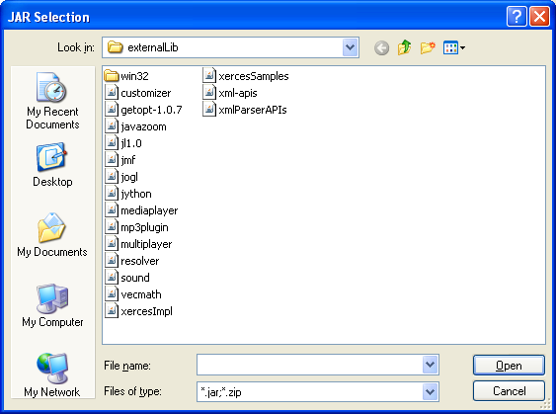

- Click JRE System Library [JavaSE-1.6] (This may differ according to the version of Java installed on your computer) and click the Edit… button.
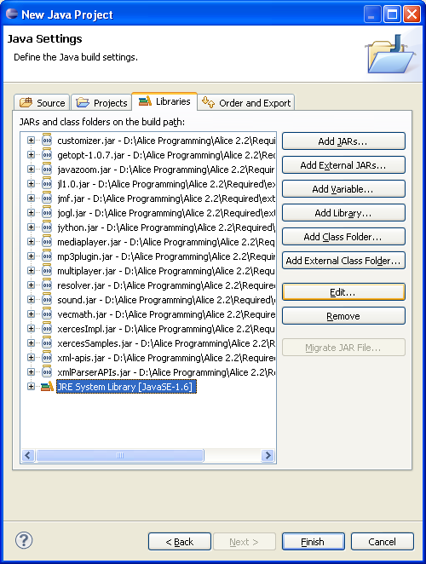

Note: We would like to use the JRE version that was provided in your Alice 2.2 – Required folder.

- Select Alternate JRE: and click the Installed JREs… button.
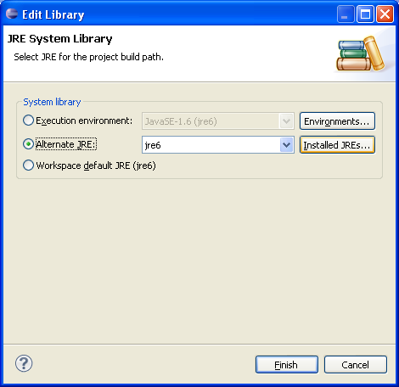

- Click the Add… button.
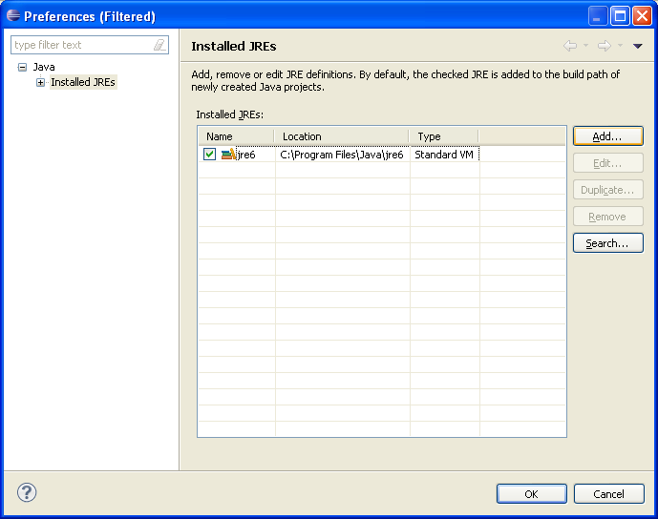

- Select Standard VM and click Next.
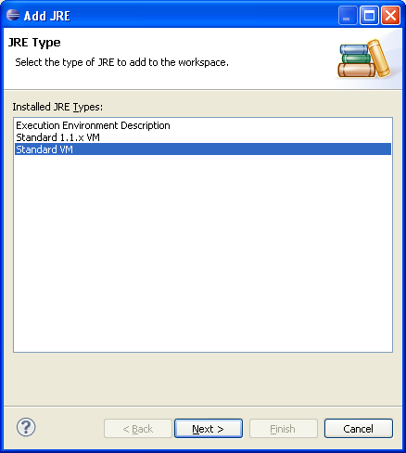

- Browse to your Alice 2.2 – Required folder and select the Jre folder.
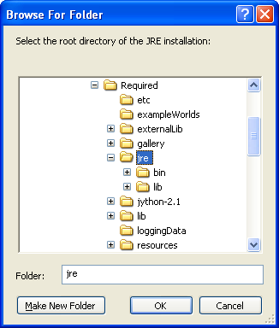
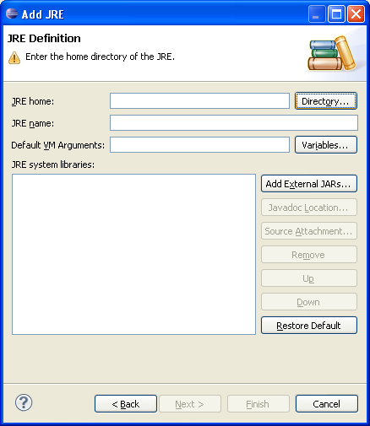

- Click Finish.
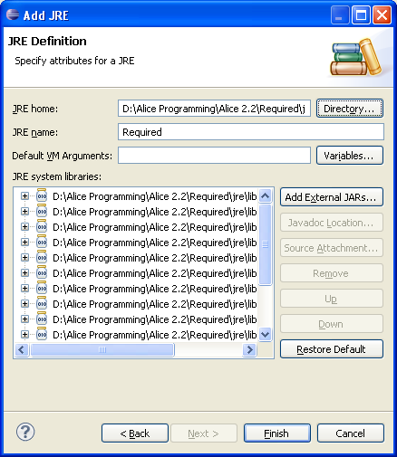

- Select the newly installed JRE, and then click OK.
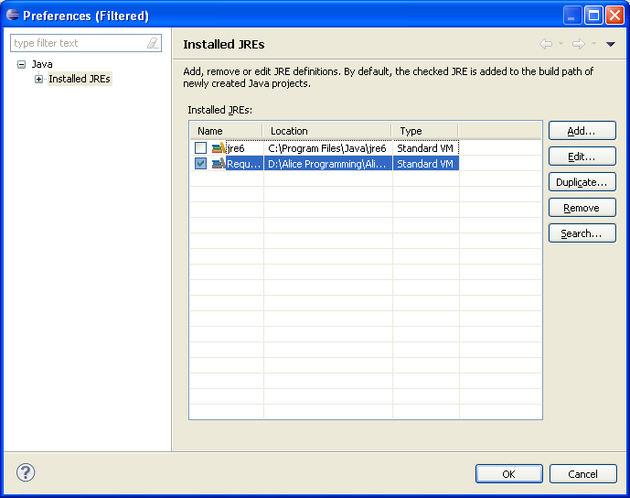

- Select the newly installed JRE, and then click Finish.
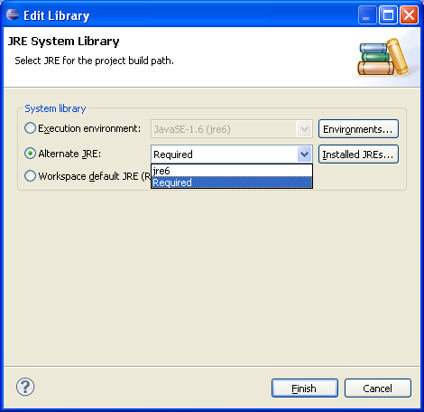

- Click Finish.
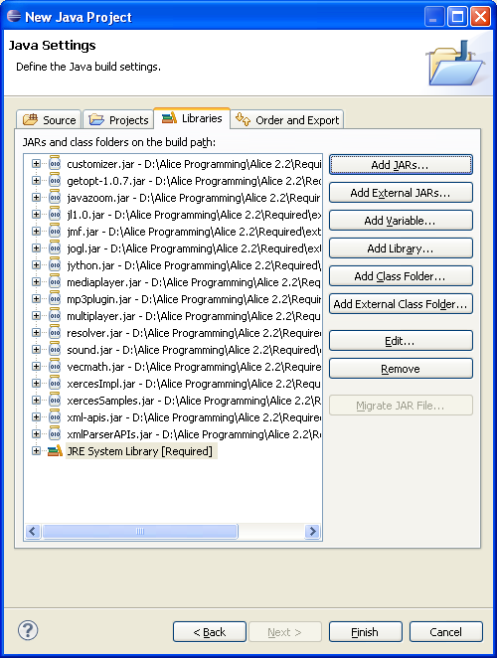

Running the program
- Select your Alice 2.2 project and click the down arrow 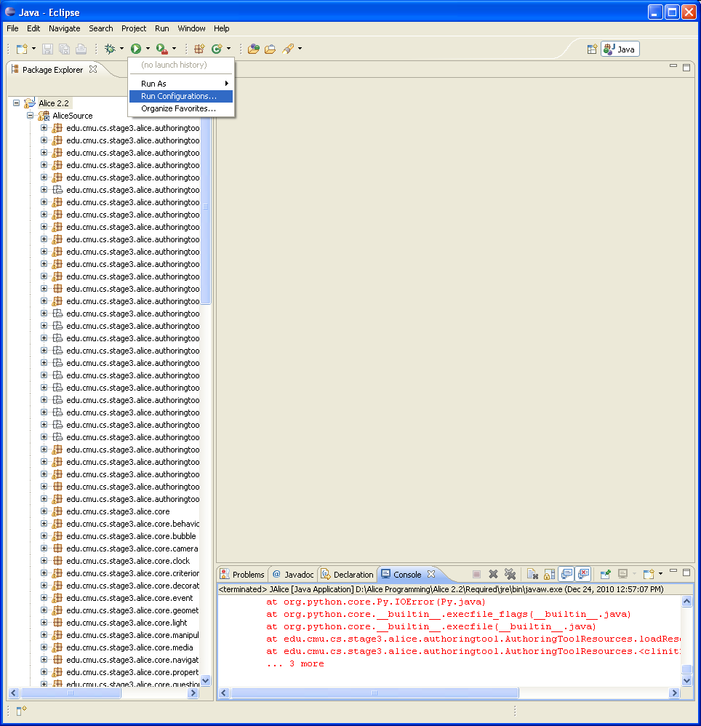 next to the Run As… 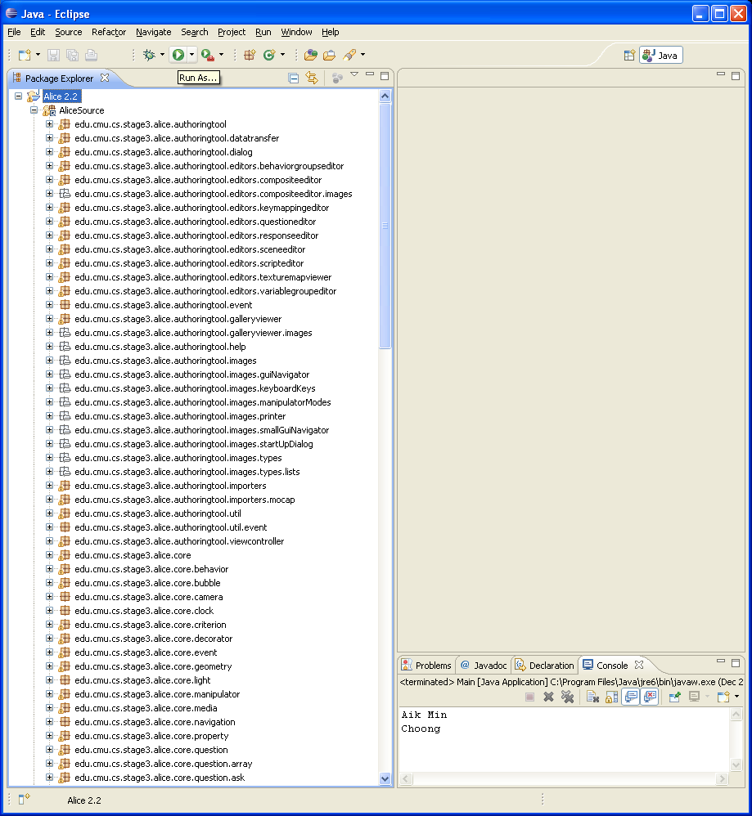 button and select Run Configurations…
- Double click on Java Application. Rename the new configuration from New_configuration to Alice 2.2 (You may use another name).
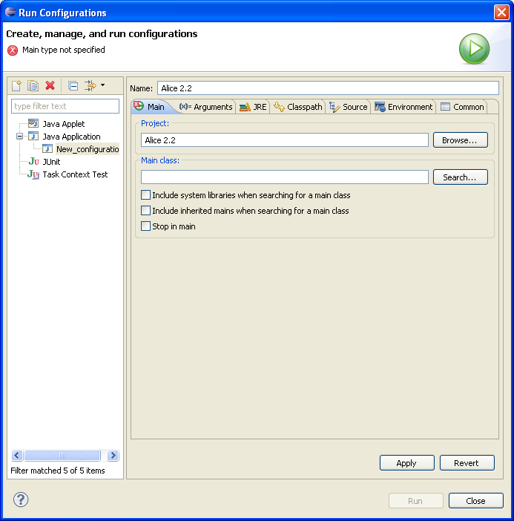

- Click the Search… button in the Main class section, and select JAlice – edu.cmu.cs.stage3.alice.authoringtool from the list.
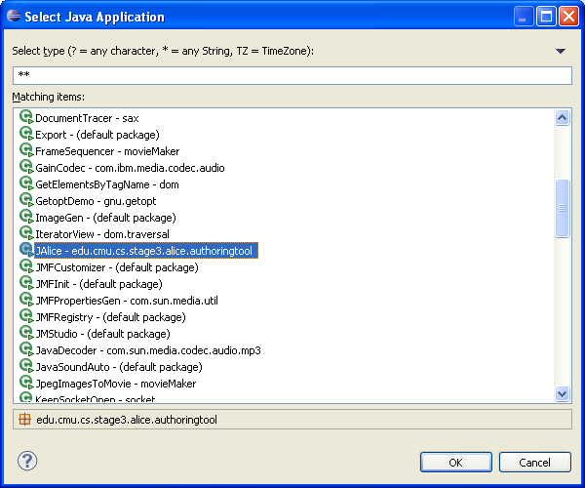
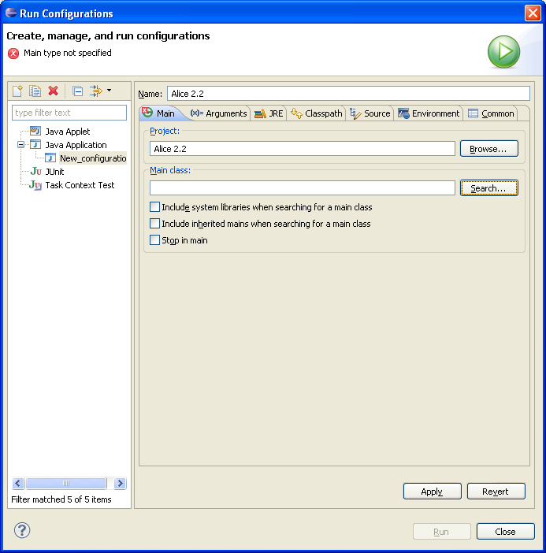

- Click the Arguments tab and type the following into the VM arguments text box.
-Xms32m -Xmx512m –Xincgc -Dpython.home=jython-2.1 -Dpython.path=jython-2.1/Lib/alice -Djava.library.path=lib/win32;externalLib/win32

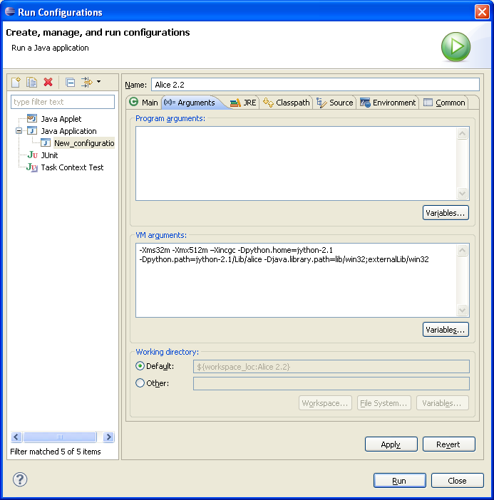
- Click Other in the Working directory section, and then click the File System… button. Browse to your Alice – Required folder, select the folder and click OK.
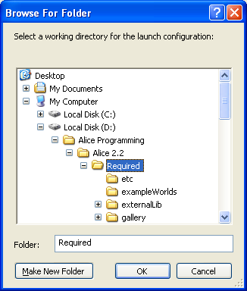
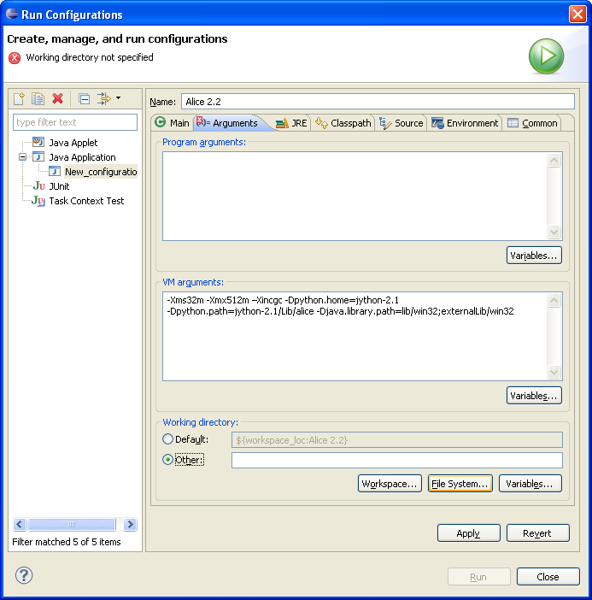

- Click Apply and then the Close button.
- To run the program, select your Alice 2.2 project and click the Run 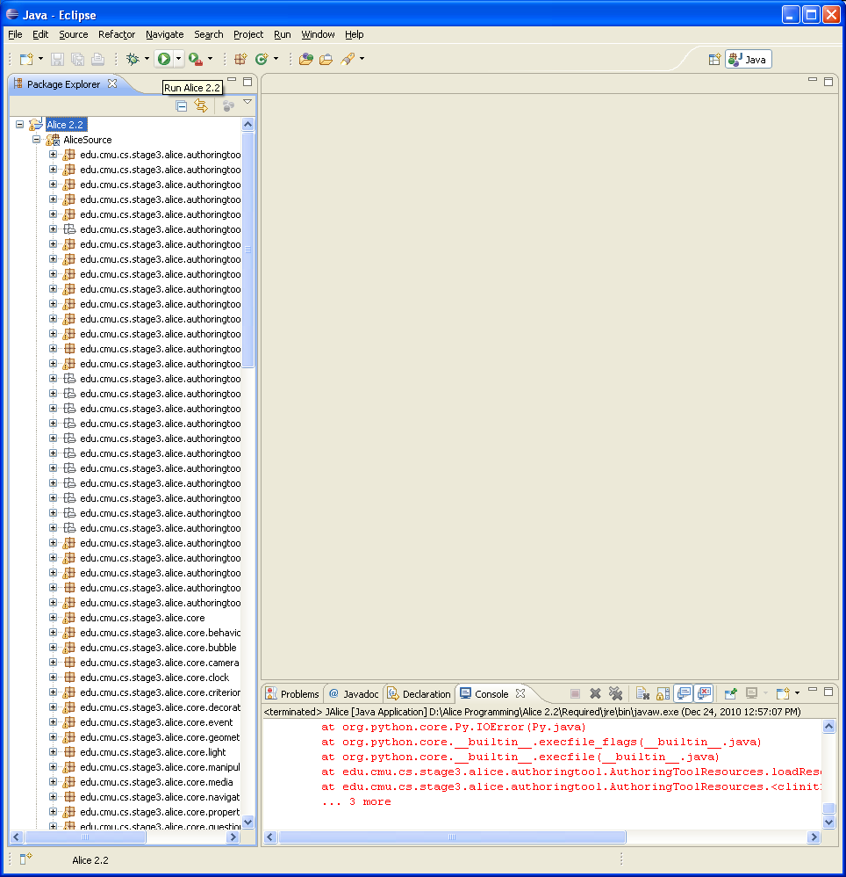 button.

Note: If you run into problems or errors showing up in the Console tab, please make sure you have installed Java JDK. Make sure you have performed the steps above correctly, and your source code if free from errors.

